**SQL ASSIGNMENT 3**

CREATE TABLE DEPARTMENT(

DEPT_ID INT NOT NULL PRIMARY KEY IDENTITY(101,1),

DEPT_NAME VARCHAR(50) NOT NULL

);

INSERT INTO [DEPARTMENT]

VALUES('IT'),

('HR'),

('MANAGMENT'),

('ADMIN'),

('TEACHING');

SELECT * FROM [DEPARTMENT]

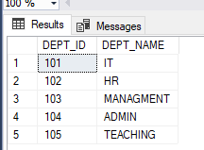

CREATE TABLE EMPLOYEE(

EMP_ID INT NOT NULL IDENTITY(1,2) PRIMARY KEY,

DEPT_ID INT NOT NULL,

MNGR_ID INT NOT NULL,

EMP_NAME VARCHAR(50),

SALARY INT );

INSERT INTO [EMPLOYEE]

VALUES(101,2,'VIVEK',50000),

(103,3,'SURESH',65000),

(104,4,'RAMESH',55000),

(102,5,'JAY',40000),

(101,6,'JATIN',30000),

(105,2,'JAYESH',20000),

(102,3,'YASH',25000),

(101,4,'DEV',35000),

(101,1,'DHAVAL',45000),

(103,1,'PRAKASH',50000),

(104,5,'CHIRAG',60000),

(105,5,'DIPAK',27000),

(103,5,'MANISH',29000);

SELECT * FROM [EMPLOYEE]

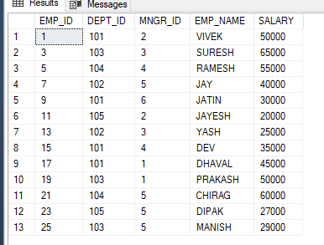

**1.**write a SQL query to find Employees who have the biggest salary in their Department

SELECT D.DEPT_ID,SALARY,E.EMP_NAME FROM

EMPLOYEE E

JOIN DEPARTMENT D

ON E.DEPT_ID=D.DEPT_ID

WHERE E.SALARY

IN(SELECT MAX(SALARY)

FROM EMPLOYEE EE,DEPARTMENT DD

GROUP BY EE.DEPT_ID HAVING D.DEPT_ID = EE.DEPT_ID)

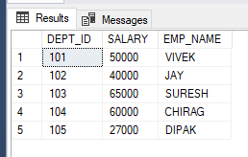

**2.**write a SQL query to find Departments that have less than 3 people in it

SELECT D.DEPT_NAME

FROM EMPLOYEE E

INNER JOIN DEPARTMENT D

ON E.DEPT_ID = D.DEPT_ID

GROUP BY D.DEPT_NAME

HAVING COUNT(E.DEPT_ID) < 3;

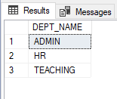

**3.** write a SQL query to find All Department along with the number of people there

SELECT D.DEPT_NAME,COUNT(E.EMP_ID) AS TOTALEMPLOYEE

FROM DEPARTMENT D

INNER JOIN EMPLOYEE E

ON D.DEPT_ID=E.DEPT_ID

GROUP BY D.DEPT_NAME

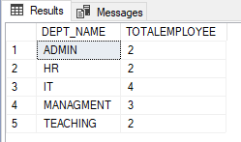

**4.**write a SQL query to find All Department along with the total salary there

SELECT D.DEPT_NAME,SUM(E.SALARY) AS TOTALSALARY

FROM DEPARTMENT D

INNER JOIN EMPLOYEE E

ON D.DEPT_ID=E.DEPT_ID

GROUP BY D.DEPT_NAME

